30 March 2007 The Weekly Bulletin of Rotary Club of Kathmandu Mid-Town Bc # 39 of 2006-07
Rotary Club of Kathmandu Mid-Town
Breakfast Chatter
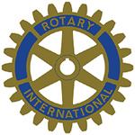



District : 3290 Web: www.rotarymidtown.org.np Club Id : 26776

MARCH IS WORLD ROTARACT (WEEK) MONTH
Rotaract builds leaders, and leaders build strong clubs with effective programs. Toward that end, clubs organize communication and public speaking seminars, training programs for club officers, workshops to organize and promote projects, and informational sessions.
Early career decisions are critical ones. To help their members make informed choices, Rotaract clubs hold
 Marketing and management seminars
 Conferences on business ethics
 Vocational and career planning counseling
 Business technology updates
Whatever they do, Rotaractors know how to have fun, make friends, and make the world a little better in the process.

Joint-meeting with Rotaract Club of Kathmandu Mid-Town on 23 March 2007
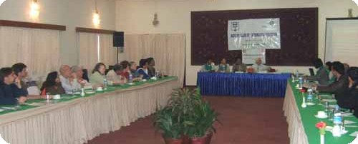
The joint meeting in session
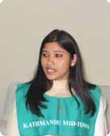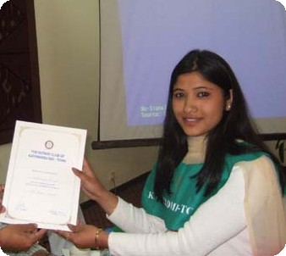
Rotaract Sadhana Thapa, as a Guest Speaker, answering to questions after her presentation on
Kenaf Plant Nepal, and acepting a letter of appreciation.

Weekly Meetings and Programs :
Date | Program/Speaker | Program/Topics of Presentation
30 March 2007 | Rabi Karmacharya | One Laptop per Child Nepal
6 April 2007 | Dr Lynn Bennett | Anthropology
13 April 2007 | No meeting | Happy New Year 2064 holiday
20 April 2007 | Club assembly | Club assembly (5)

Friday, 30 March :
Inhouse speaker - Club Secretary Rabi Karmacharya will be giving a presentation on One Laptop Per Child Nepal.

Tourism in Dubai :
Dubai has 1 million population whereas it receives annual tourist arrivals of 5 millions. The government plans to have 10 million tourist arrivals by the year 2007, and 40 million tourist arrivals by the year 2015.

Women only island :
Iran is seeking to create a paradise for female tourists by turning an island on a northwestern lake into male-free zone. All public transport, restaurants and facilities on the island – on the gigantic Oroumiyeh lake close to the Turkish border – will be staffed only by women. The island of Arezou, one of the 102 islands in the Oroumiyeh Lake, will be equipped especially for women, Tehran Emrouz newspaper reports. There will be no men on the island. It will also boost tourism in the area. The construction of hotels, restaurants and medical centers under the management of women is one of the specifications for this island.
Source: The Himalayan Times

On Lighter Side : Click at the figure ⇩


As Rotarians, we should have The Four-Way Test in the back of our minds - if not the front - in every decision we make, all day long. We must also make it known that we will not compromise our ethical standards. Hanging The Four-Way Test on the wall for all to see sends a clear message: Rotarians are people of integrity who care.
RI President William B. Boyd

30 March 2007 The Weekly Bulletin of Rotary Club of Kathmandu Mid-Town Bc # 39 of 2006-07

Editor: RR Shrestha, Club Service Director email: rryes@wlink.com.np

